

Asia pacific College

#3 Humabon Place, Magallanes, Makati City

Loyola Student Center  
Learning Management System

Project Documentation Submitted

to the Faculty of School of Computer Science and

Technology of Asia Pacific College

In Partial Fulfillment of the Requirements for the subject

Structured System Analysis and Design

Gardon,Jana Marie G.

Heramia, Johanna Marisse C.

Tadeo, Jose Lorenzo G.

MI-141

Mr. Manuel Sebastian Sanchez

Professor

**Project Description**

The LSC Learning Management System is for the students and for the management of Loyola Student. This system will help the student to track their grades based on their tasks completed. Student can analyze whether they need more improvement in a certain course or subject. Student can be notified easily if there are announcements from the management of Loyola Student Center. In the management side, system can help them through management of the student's courses. Under a course, there are many subjects and under those subjects there are specific tasks that they can create and update. Management can easily see students under a specific course and can easily track the attendance of students.

The following are the Loyola Student Center's current system:

■ The schedule is given by the instructor manually and the student will write it on the paper.  
■ The student's summary of grades can't be seen by the student unless he/she asks.  
■ The activity of the student such as assignments or quizzes is paper based.  
■ If the student already changed their personal information, the admin will not be able to know unless the admin asks for it or vice versa.

This current system's difficulty will be improvising by having Loyola Student Center - Learning Management System. It helps the student and administrator/instructor to have easier administration, faster administration of student's records online, taking activity, efficient way of gathering reports and summarization of student's performance. The following are the propose system's improvement:

■ The student can view his/her schedule online.  
■ The student can view his/her summary of grades together with their attendance.  
■ The student can take exercises/homework/quizzes online.  
■ Student can easily update their information if there are any changes.  
■ The admin can easily view student's attendance, can view summary of grades, can update or add exercises, homework and quizzes.

Building this system will benefit the following:

*To the Students*

Students of Loyola Student Center (LSC) can benefit the system in many ways. Students can use the system anywhere. They only need an internet connection to allow them to connect to the system. Student can check their schedule whether a change has been made or not. Students can check if they missed a class or not. Students can take and pass their homework without using a paper and student can view his or her performance at the center through the system by viewing his or her grades.

*To the Parents*

LMS utilize websites for teaching much information in a convenient way for parents as well. Using LMS allows parents to review the course curriculum, classroom calendar and monitor their student's progress. It simultaneously keeping parents updated with what is going on by informing them through email or through message.

*To the Administrators*

Administrating a tutorial center manually is not easy if they have numerous of students enrolled. Recording grades, recording attendance, giving away quizzes, exercises and homework through paper is one of the vital part of the existing system that needs to be address. That is the reason why administrator can benefit from this system because: 1. They can give assignments, homework or quizzes online right away. 2. They can easily track student's attendance and grades.

### Objectives

#### General Objectives

■ To provide student an efficient way of learning by using the Learning Management System.  
■ To give student the student a faster tracking of their performance and what is needed to improve.

■ To provide easier administration.

#### Specific Objectives

■ To provide the Loyola Student center with a system for the learning management system and a database for their requirements.  
■ For faster administration of records of the task, grades and attendance of students.  
■ For the administrator to announce updates faster.  
■ For the students of Loyola Student Center to have easier access on their progress online.

**Scope and Limitations**

The coverage of LSC Learning Management System are:

■ Administrator can create and update course and under course, there are many subjects.

■ Instructor can add tasks such as quizzes, exams and exercises.   
■ Administration can add announcements on calendars.   
■ Student can take tasks.

■ Student can view their grades and attendance.

The LSC Learning Management system is only limited for the students of Loyola Student Center. This system will not cover the enrollment of students; therefore, it is assumed that the student is already enrolled. Students who are enrolled will automatically have an account.

**Review of Related Literature**

**Moodle** is the most popular open-source learning management system (LMS) in the world. They've implemented Moodle LMS in hundreds of businesses, schools, colleges and training organizations around the world. They provide the full range of Moodle services, from theme design and consultation, to installation, training and technical support. Documentation, trackers and resources are all provided through Moodle. The site does not have a specific "K-12" product, however, if a teacher or administrator is tech-savvy enough, they can bend the program to their school or district's needs. The following are the functions of Moodle:

■ Organize and display courses the way user want, and view at a glance current tasks and messages.   
■ Moodle’s calendar tool helps keep track of academic or company calendar, course deadlines, group meetings, and other personal events.   
■ Format text and conveniently add media and images with an editor that works across all web browsers and devices.   
■ When enabled, users can receive automatic alerts on new assignments and deadlines, forum posts and also send private messages to one another.   
■ Educators and learners can track progress and completion with an array of options for tracking individual activities or resources and at course level.   
(<https://docs.moodle.org/31/en/Features>)

**Learnanywhere** is an LMS which we've created specifically for elementary schools. The interface is designed to be simple to use and easy for young students to get to grips with. It includes a reward system to help encourage younger learners to succeed in their work. The system is hosted in the cloud, allowing students and teachers access from home or school. Learnanywhere makes the process of creating courses, activities and quizzes easy for teachers, saving valuable time, and helps to engage parents in their children's learning. These are the functions of Learnanywhere:

■ Add multimedia content, and celebrate achievement with on-screen rewards and customizable learning buddies.   
■ Keep parents up to date on their child's progress with MIS integration, parent forums and online newsletters.   
■ Set self-marking quizzes to cut down on marking, and store resources online for easy access.   
■ Expert help and advice via free phone, email and live web chat whenever you need it.   
■ Assign personalized study aids and extension activities. Tailor resources according to ability.   
(<http://learnanywhere.co.uk/features/>)

**Technical Background**

The LSC Learning Managament System was built using Yii2 advanced framework in both frontend and backend. Frontend is for the students andbackend is for the administrator. Yii is an open source, object-oriented, component-based MVC PHP web application framework. Models and CRUD were generated and modified easily. To connect and store data, Apache Web Server and XAMPP Control Panel was used. All the data gathered are stored in a database powered by MySQL.

**Methodology**

Once the student was already enrolled in LSC, he/she will automatically have a LSC-LMS account. The student must log-in first to be able to view his/her schedule and if there are announcement student willbe able to notify if there is an upcoming event through the LMS calendar automatically. The attendance of the student can also be viewed. The student can take quiz, assignment or exercises. Allthe scores that was recordedcan be checked. The profile information of the student is also included in the system and can still be able to update by the student.

**Requirements Analysis**

After meeting with the client, we come up with the idea of having a learning management system since their current system is still paper-based process. The reason why they are still using papers when giving quizzes, exercises and homework is because they are concerned with the security of their materials. They do not want their materials to be printed or to be print screened. So, the LSC Learning Management System must be very well secured not just with the materials, but also with the students and administration accounts. Everything must be secured and must be efficient to the user of the system.

**Requirements Documentation**

After meeting with the client and discussed about the project, we came up with list of requirements:

■ The enrolled student must have a LSC-LMS account.   
■ On the frontend side, the student can view his/her attendance and schedule.   
■ The student can update his/her profile.   
■ The student can view the upcoming events or task in the calendar.   
■ The student can take quizzes, assignments or exercises.   
■ The student can view his/her score from the tasks.   
■ On the backend side, admin can create courses and subjects underneath.   
■ The admin can update quiz, assignments or exercises.   
■ The admin can monitor the student's attendance.

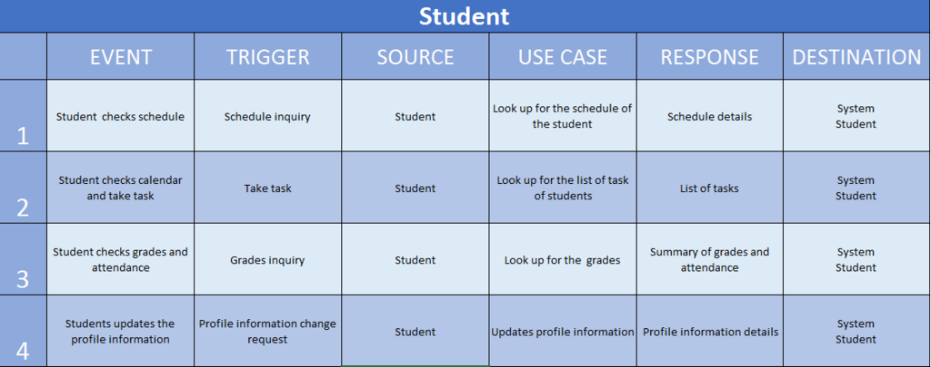

**Event Table**

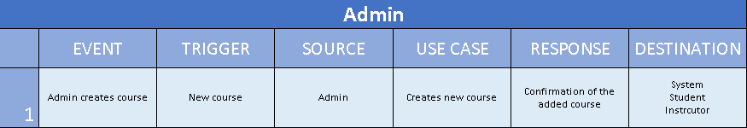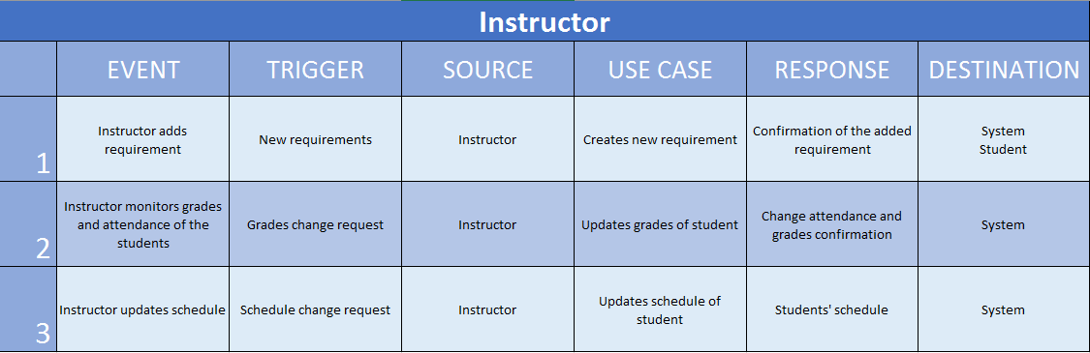

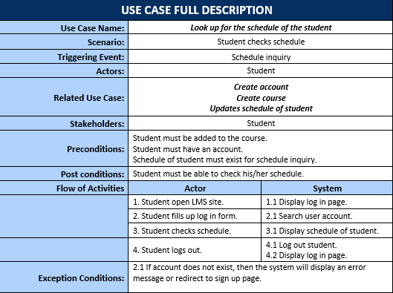**Use Case Full Description(Student)**

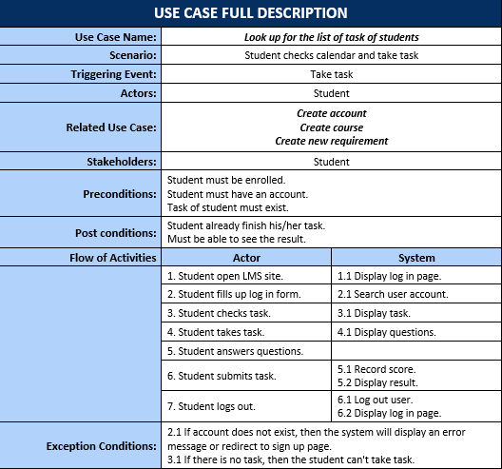

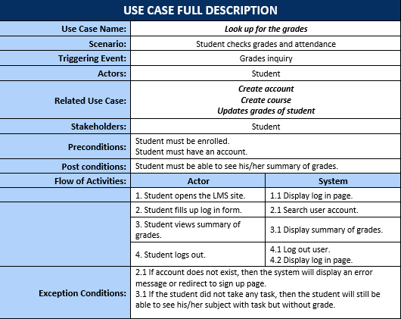

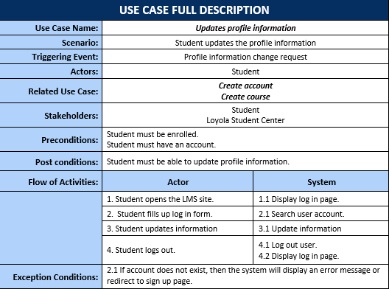

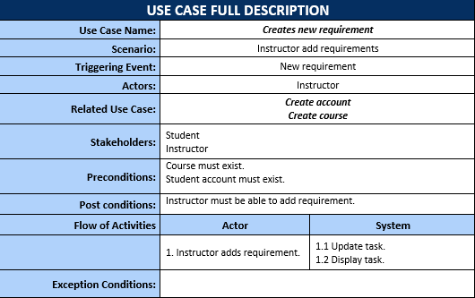**Use Case Full Description(Instructor)**

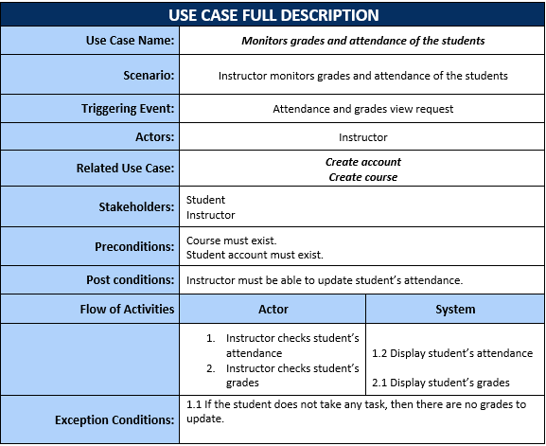

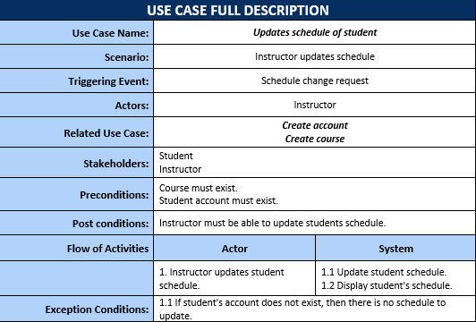

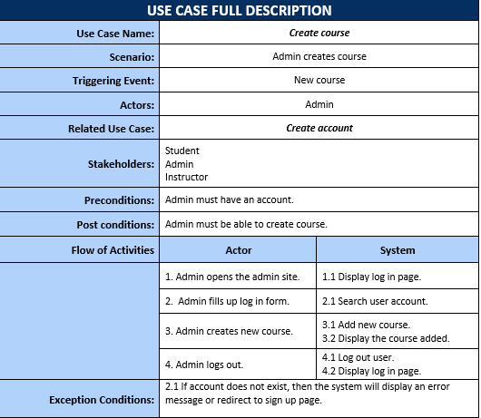

**Use Case Diagram (Student)**

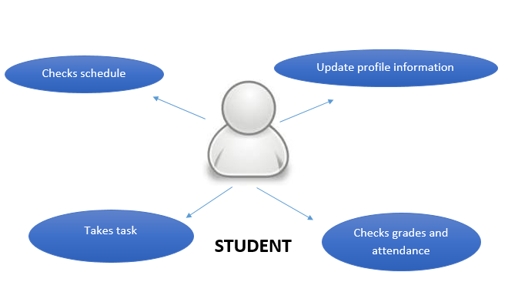

**Use case Diagram (Employee)**

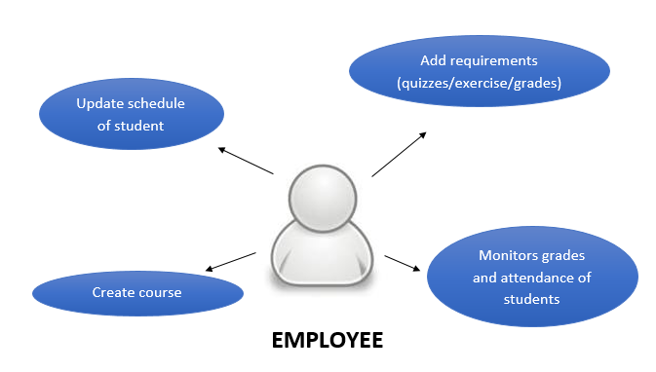

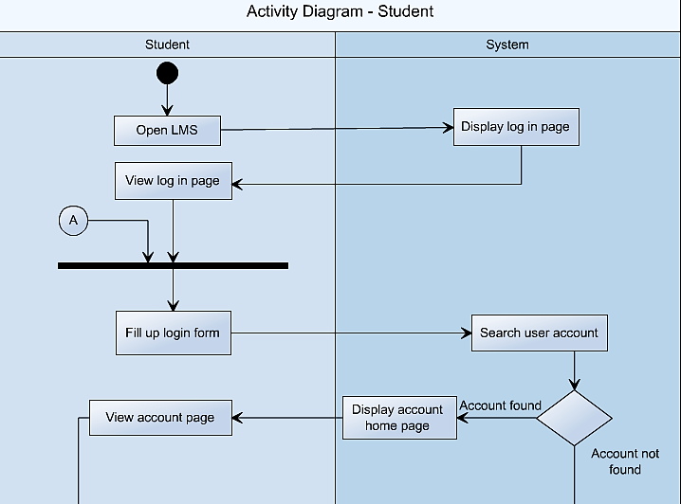

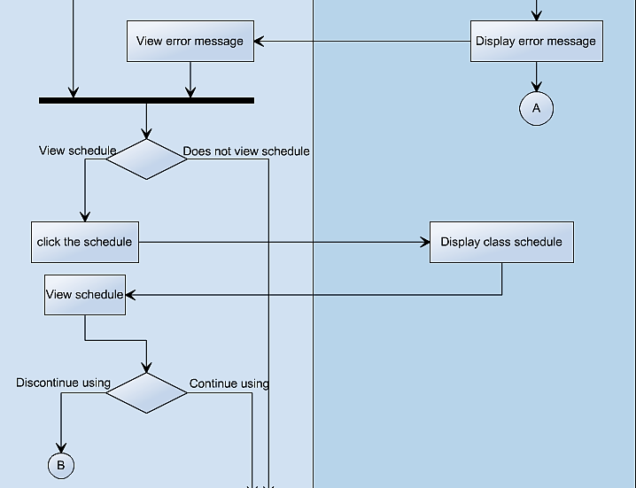

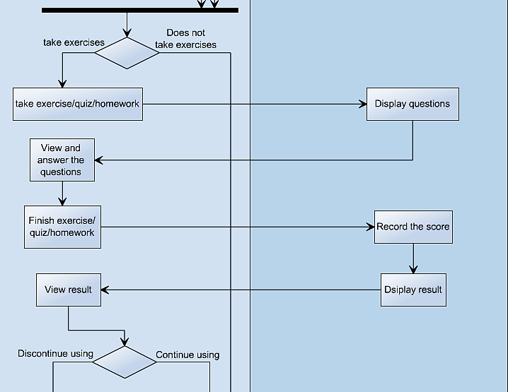

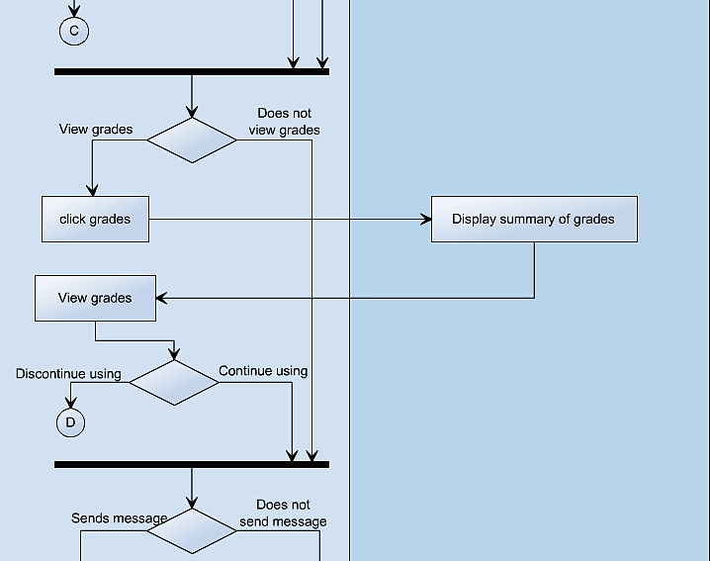

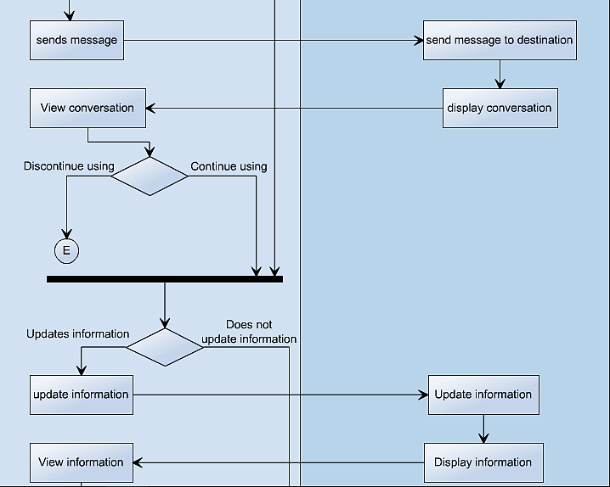

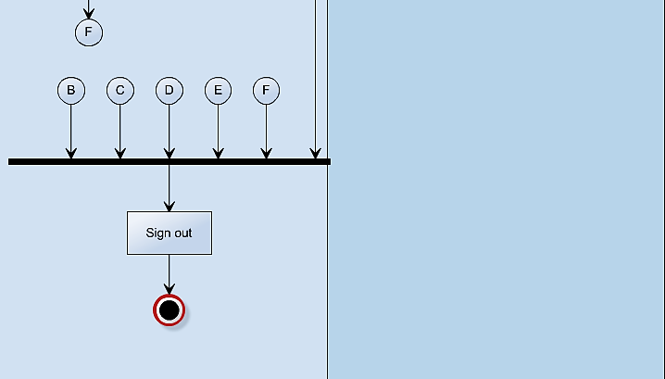

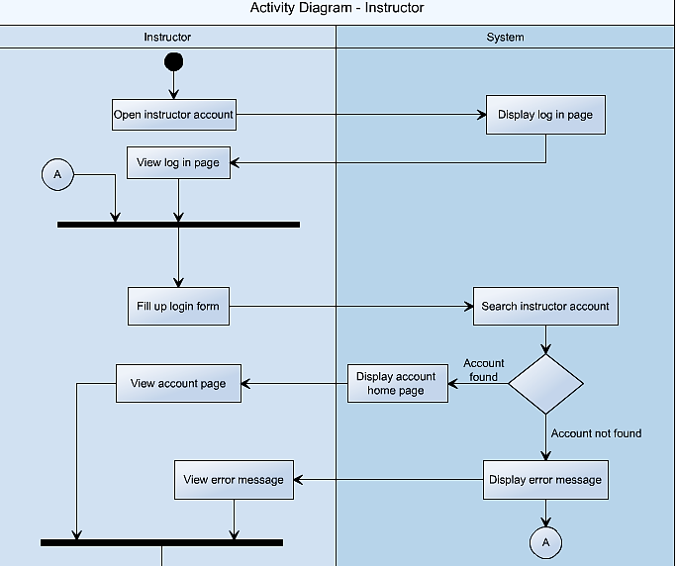11

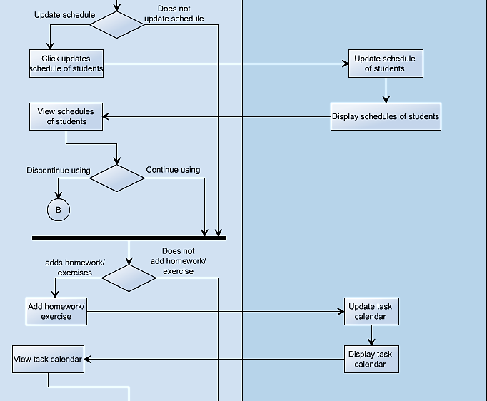

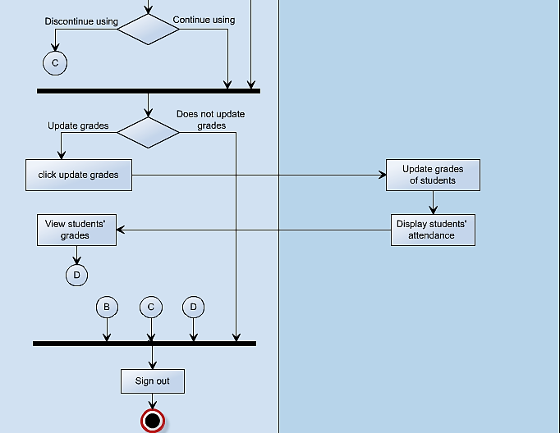

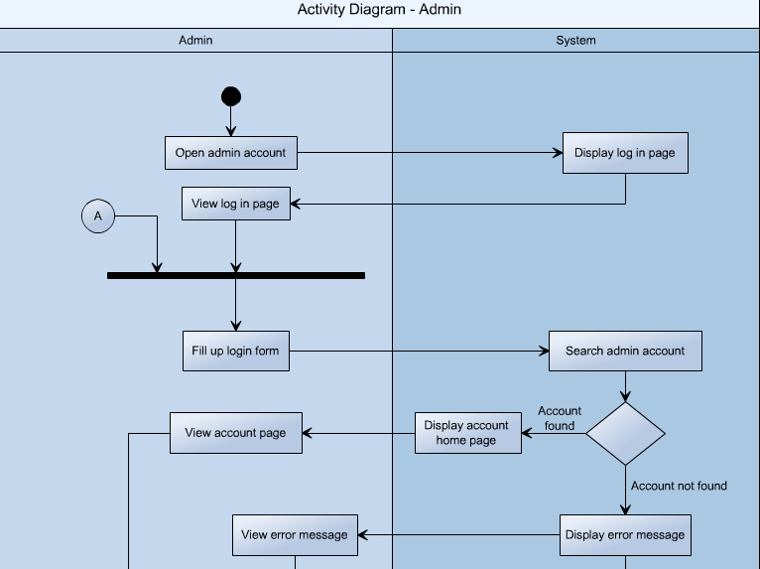

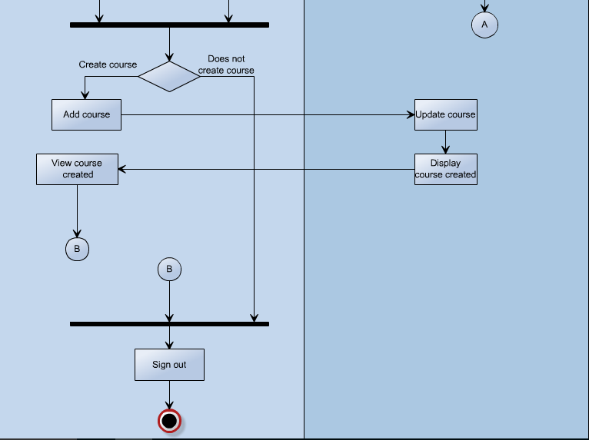

**Object Diagram**

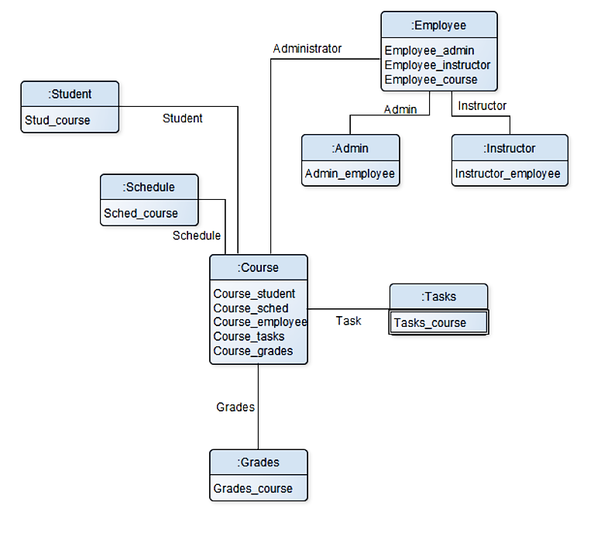

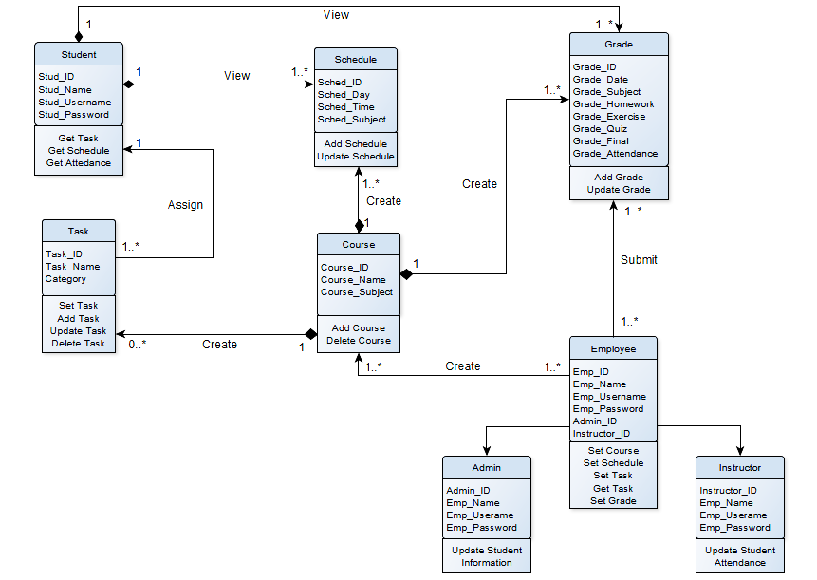**Class Diagram**

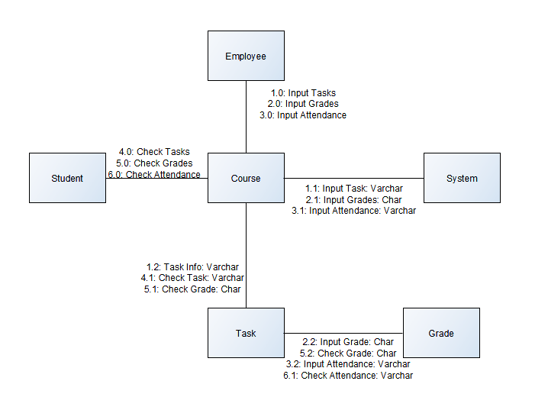**Communication Diagram**

**State Machine Diagram**

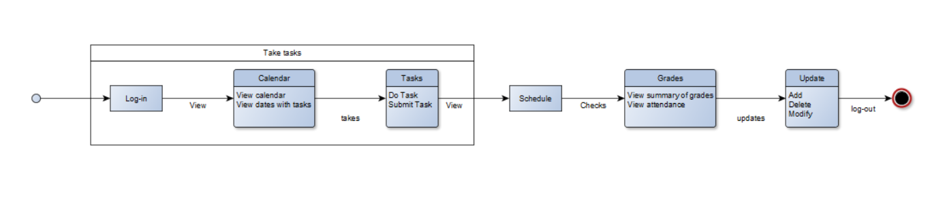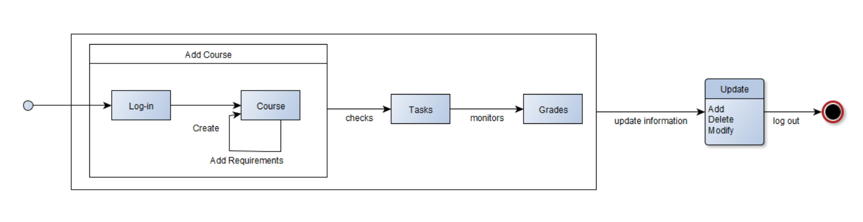

**Employee**

**Student**

**State Machine Diagram (Student)**

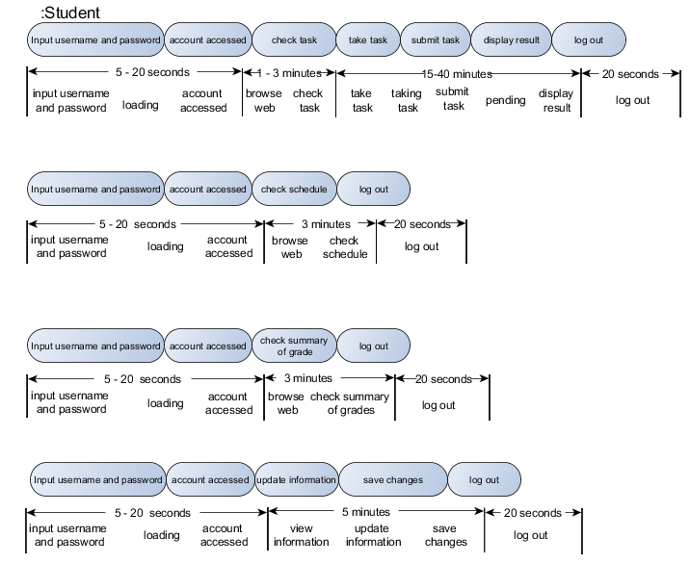

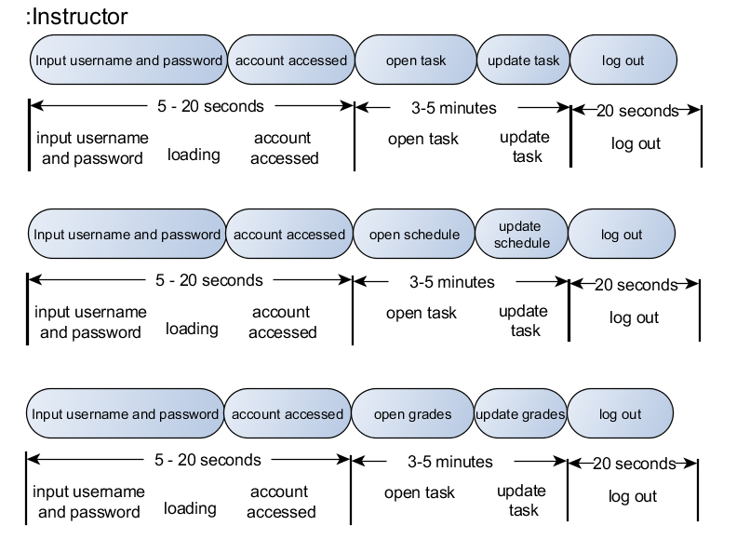

**State Machine Diagram (Instructor)**

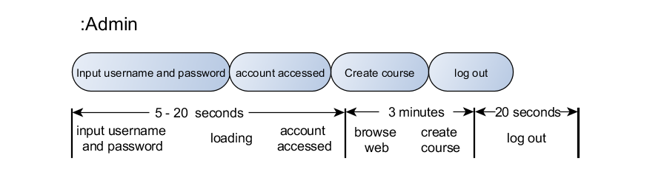

**State Machine Diagram (Admin)**

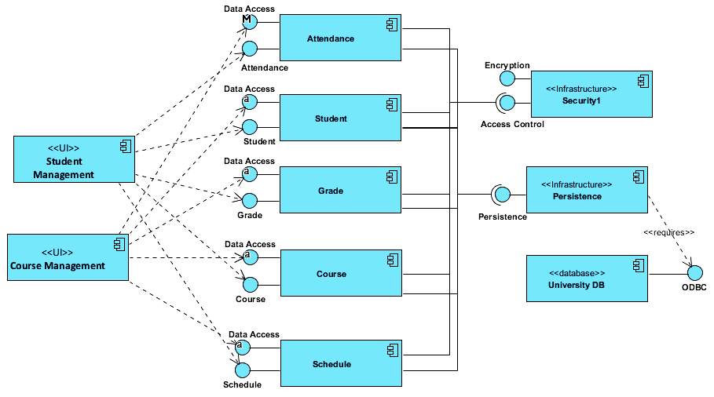

**Component Diagram**

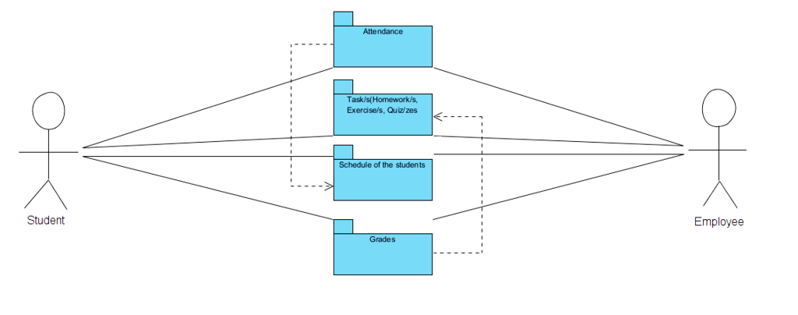**Package Diagram**

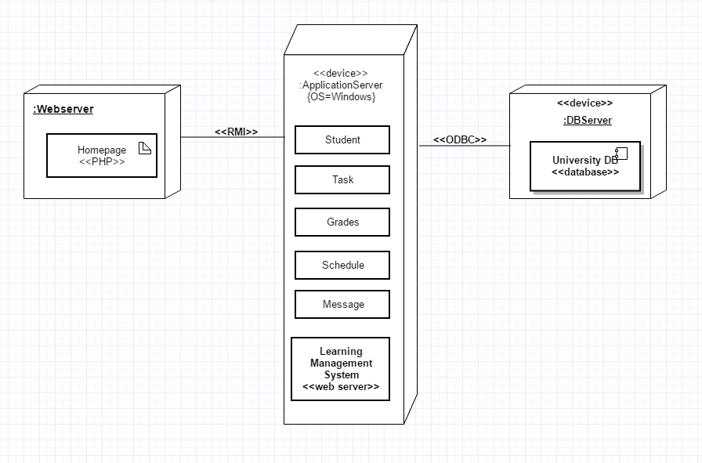**Deployment Diagram**

**Sequence Diagram**

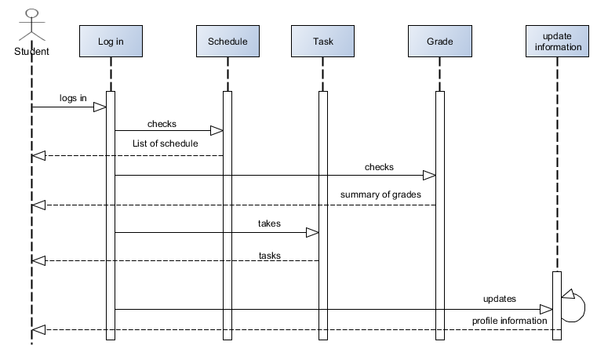

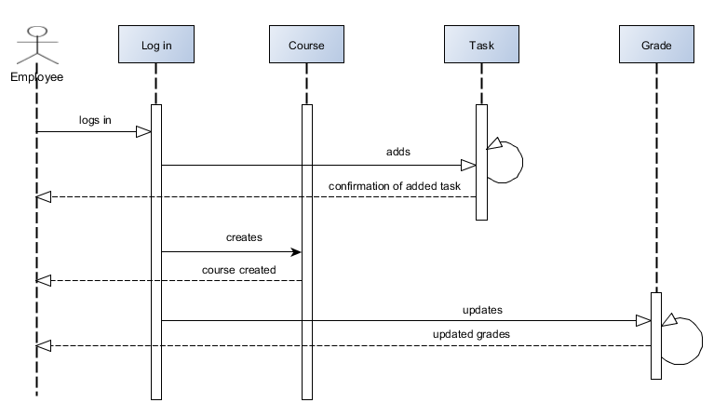

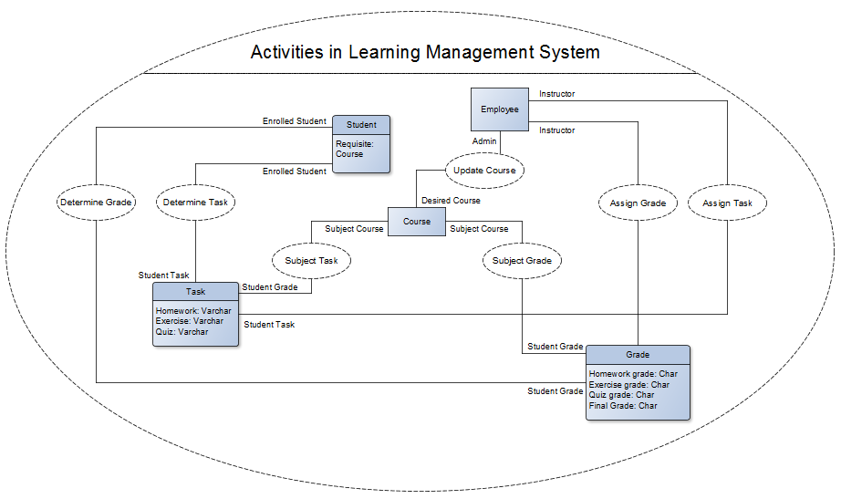

**Interaction Diagram**

**Interaction Diagram**

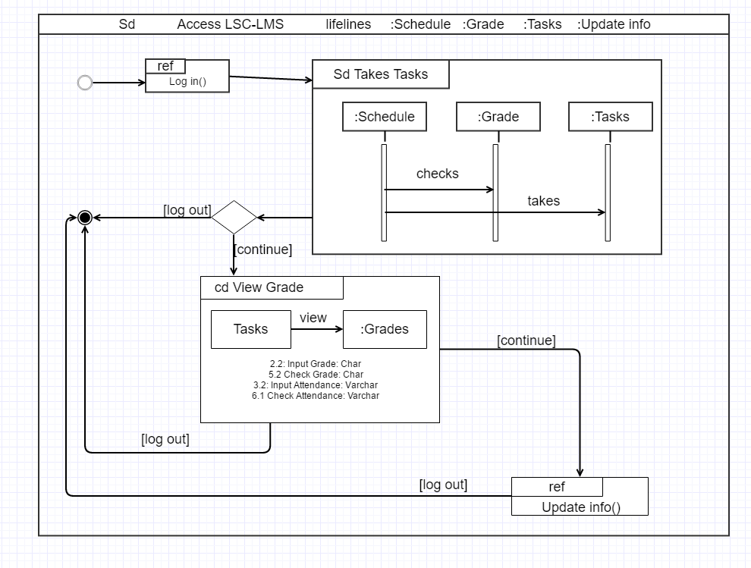

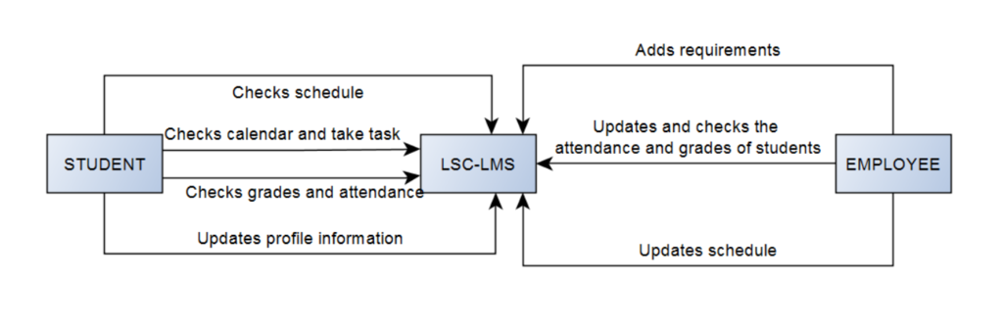

**Context Flow Diagram**

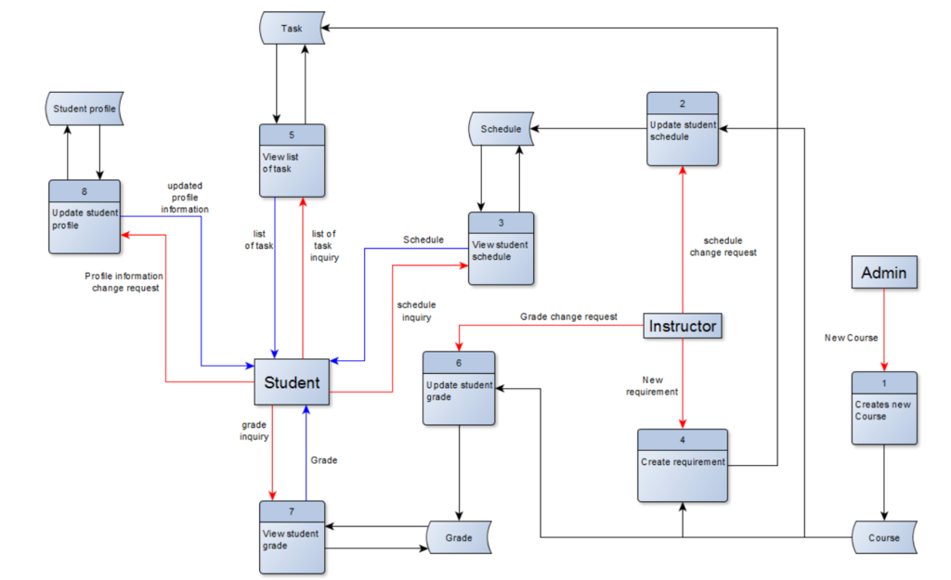

**Data Flow Diagram (Level 0)**

#### CreateReq_zpsyqf0nkkw.png**Data Flow Diagram - Level 1 Create Requirement**

#### **Data Flow Diagram - Level 1 Update Student Grade**

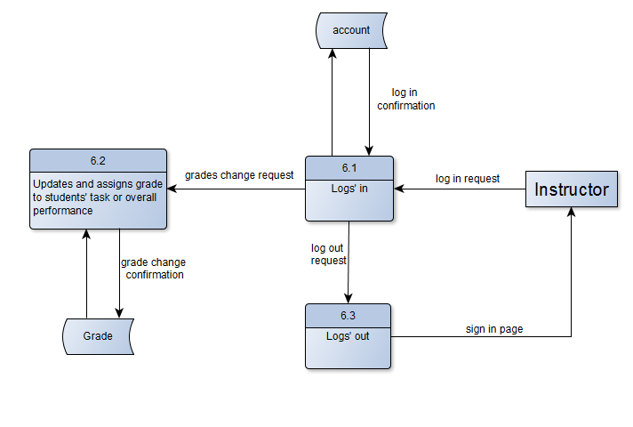

#### **Data Flow Diagram - Level 1 Update Student Profile**

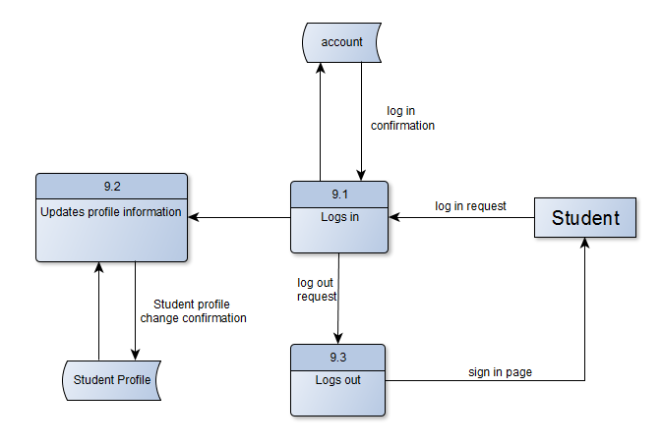

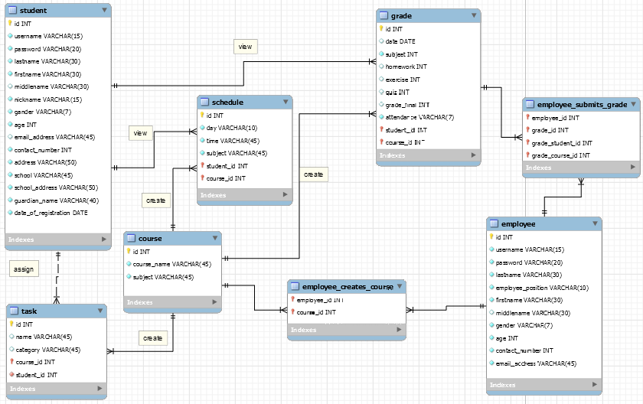

**Data Flow Diagram (Level 0)**

### One-Page Curriculum Vitae per team member

### Jana_Vitae_zpsgz5sdgui.png

### vitae%20j1_zpslgnfrusm.png



